**SBA-10 HELANI PAUL**

1. Write a Binary search program to search the elements of the integer Array.

**PROGRAM**

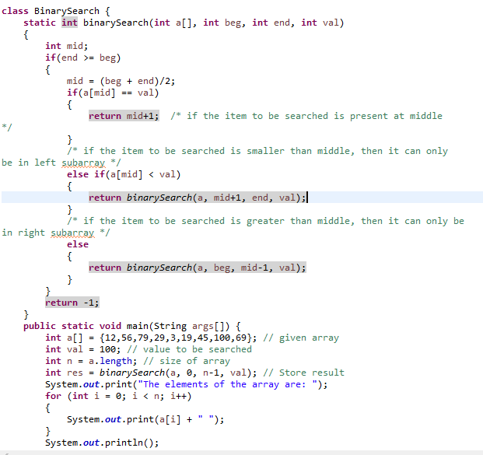

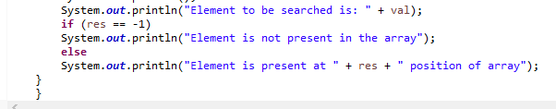

**OUTPUT**

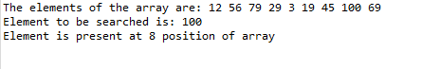

1. Create a login page using the Bootstrap and also include the Typescript and ES6 features like Loops, If-else conditions.

